Better utilization of hospice could reduce readmissions for circulatory patients
In 2018, Piedmont Hospital saw 2234 Medicare patients with a primary diagnostic category of Circulatory System. For those patients, hospice utilization upon discharge was 3.7%. That is 31% lower than the county average of 5.4%! The difference in utilization (1.7%) represents about 38 patients.
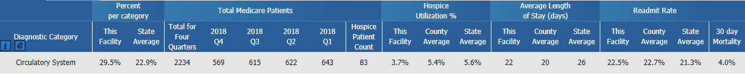
Figure 1: Medicare patients with a primary Major Diagnostic Category of Circulatory System that entered hospice care within 30 days of hospital discharge.

Keep in mind that readmission rates for patients discharged to hospice are considerably lower than other post-acute settings. For Piedmont Hospital, the all cause readmission rate for 2017-2018 was 17.8%. For patients discharged to hospice that number is only 3.2%. Note also that the readmission rate for hospice patients at Piedmont is 14% higher than the county average.

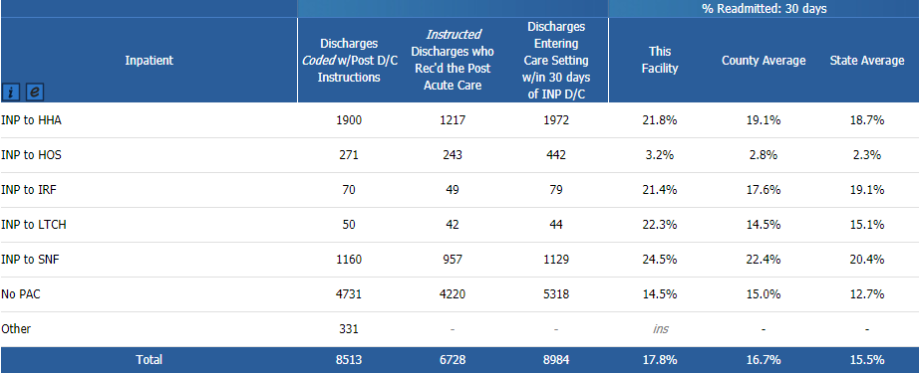
Figure 2: Outpatient discharges for Medicare patients by post-acute care setting.

Hospice Atlanta performs exceptionally well with circulatory patients
Hospice Atlanta provides hospice to a high number of circulatory patients. They represent our second largest major diagnostic category. More important than volume is our outcomes. At 3.5%, our Hospitalization +30 rate is 35% below the county average of 5.4%. Hospitalization +30 rate tracks all admissions to the hospital while on hospice and 30 days after hospice revocation.

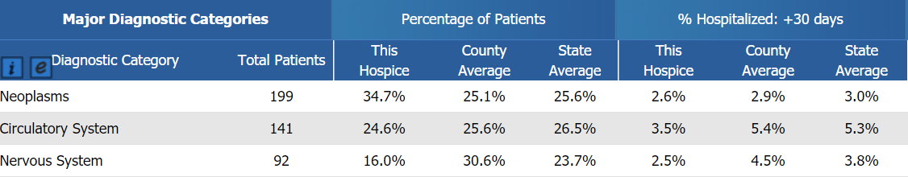
Figure 3: Hospice patients by primary Diagnostic Category for Hospice Atlanta.

Partnership Recommendation
Our experience has shown that although clinical staff may know the benefits of hospice, they may not be having the necessary conversations such that a patient and their family are comfortable electing for hospice at discharge. We’d like to work with the Cardiology department to (1) identify better approaches for educating patients and their caretakers on hospice care and (2) streamlining the approach to scheduling a hospice consultation.

About Excel Health
Excel Health solutions give business leaders an active picture of the post-acute care activity in their service areas so they can better understand peer and provider performance metrics. As one of only a few companies in CMS’s Innovator Research Program, Excel Health has immediate access to the complete Medicare Part A and Part B data. Their solution analyzes the most intricate components of more than 1.25 billion claims and presents the relevant insights to hundreds of post-acute care organizations so they can build high-performing care networks.

